# SERHANT CONSTRUCTION COMPANY PAYROLL SYSTEM

The homepage would essentially be the “Staff-Dashboard-view”. But due to Login restrictions, Users are automatically redirected to the Staff Login upon visiting the app, forcing them to first login before gaining access to the App.

“The Staff-Login-Page” includes a button to access the “Admin-Login-Page” and a staff login form, which accepts and verifies the user’s email and password. If valid information was submitted the user will gain access to the “Staff-Dashboard”.

**STAFF LOGIN PAGE**

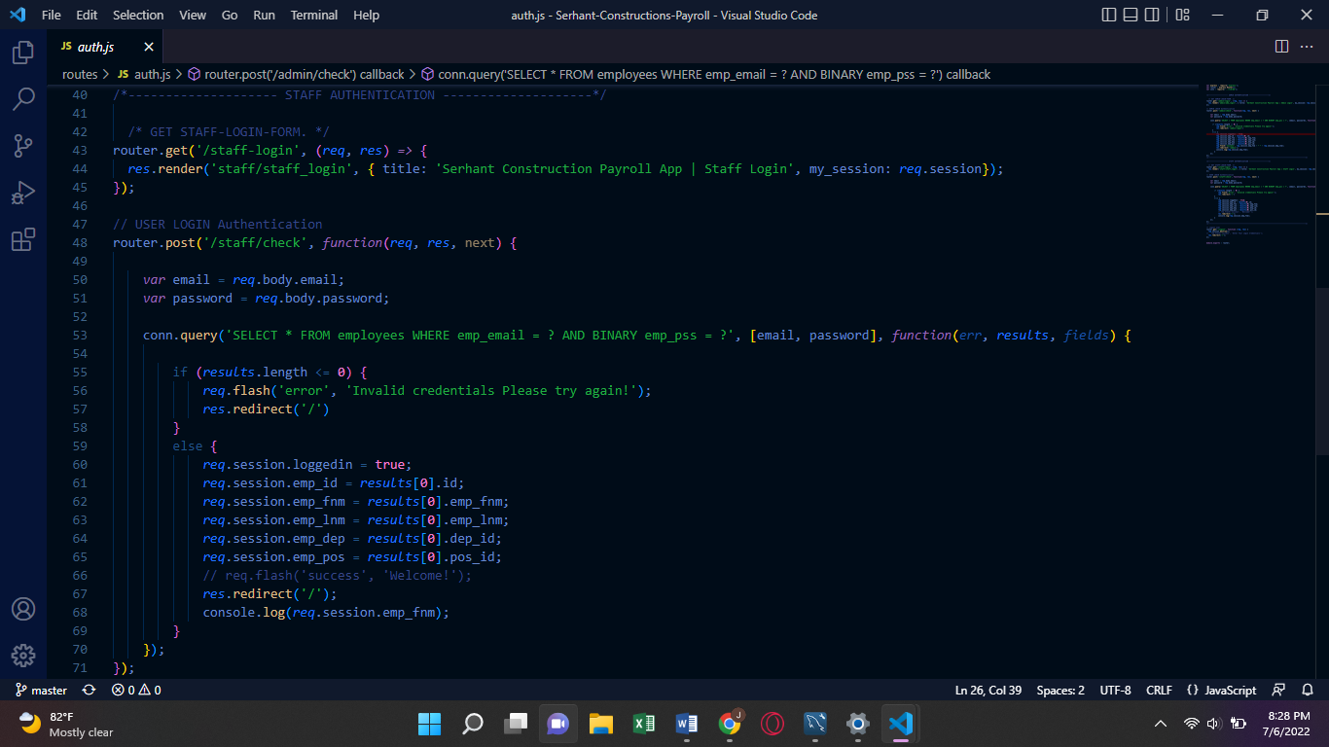

-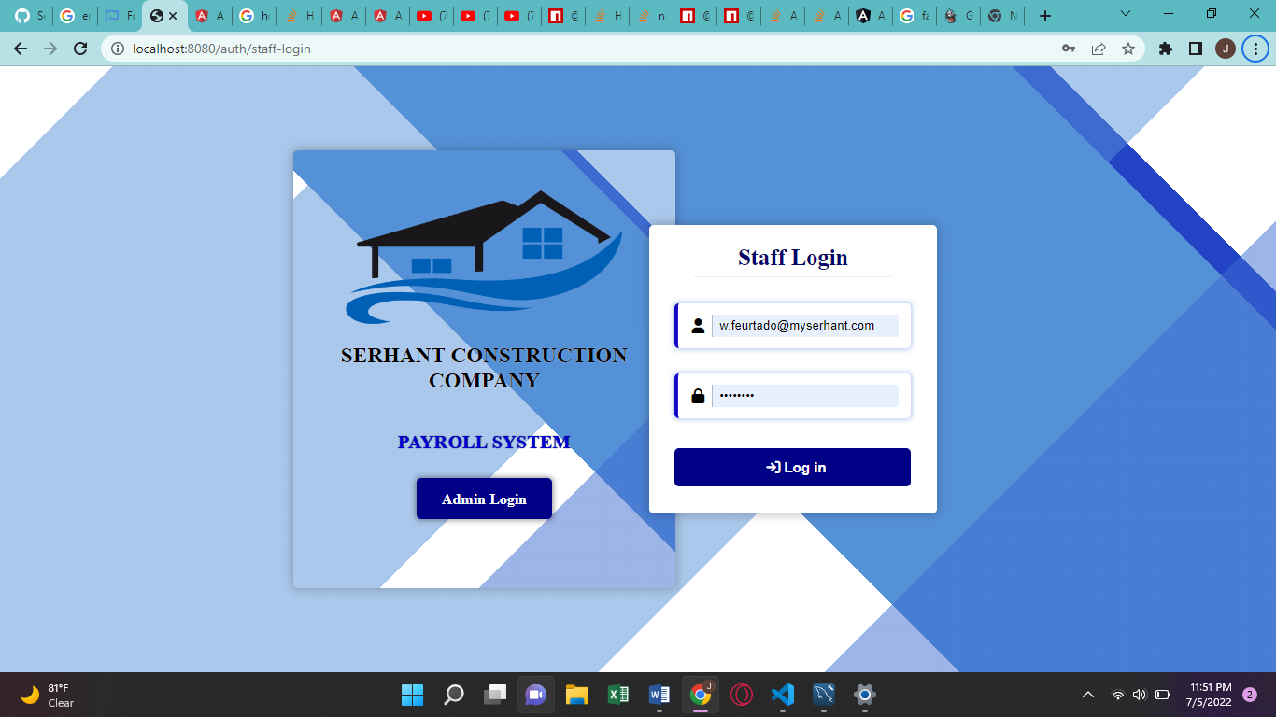

**STAFF DASHBOARD /HOME PAGE**

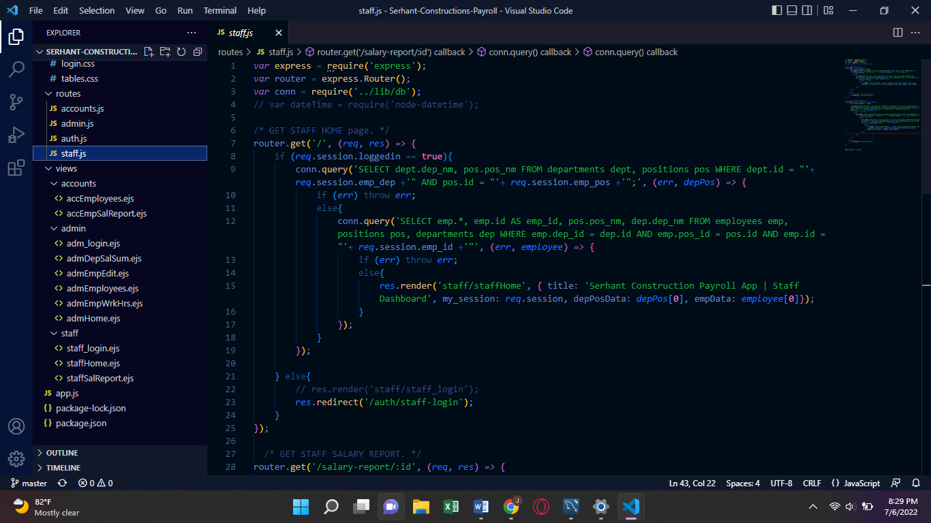

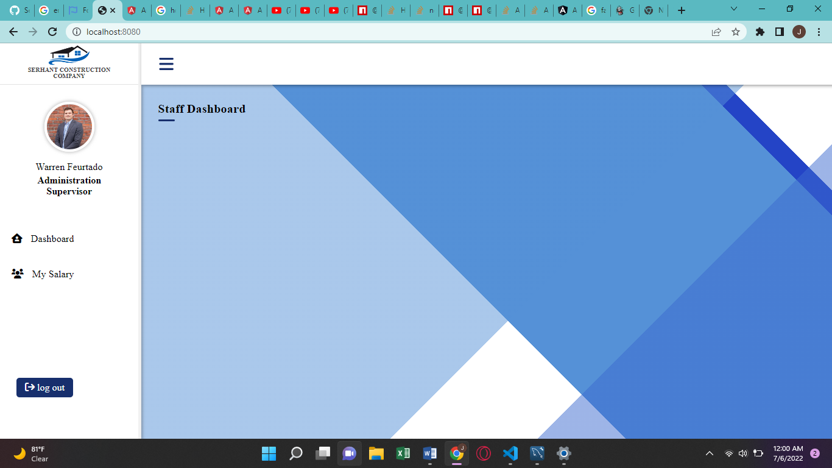

The “STAFF-DASBOARD” tells who is logged in, their department and their position in the sidebar, which may be closed or opened by clicking the menu bars icon in the left corner of the top horizontal nav-bar.

The side bar also contains a log out button as well as a link to the main staff dashboard, and a link to view their Salary Reports.

All Staff members have access to the Staff Dashboard upon successful login.

**STAFF SALARY REPORTS PAGE**

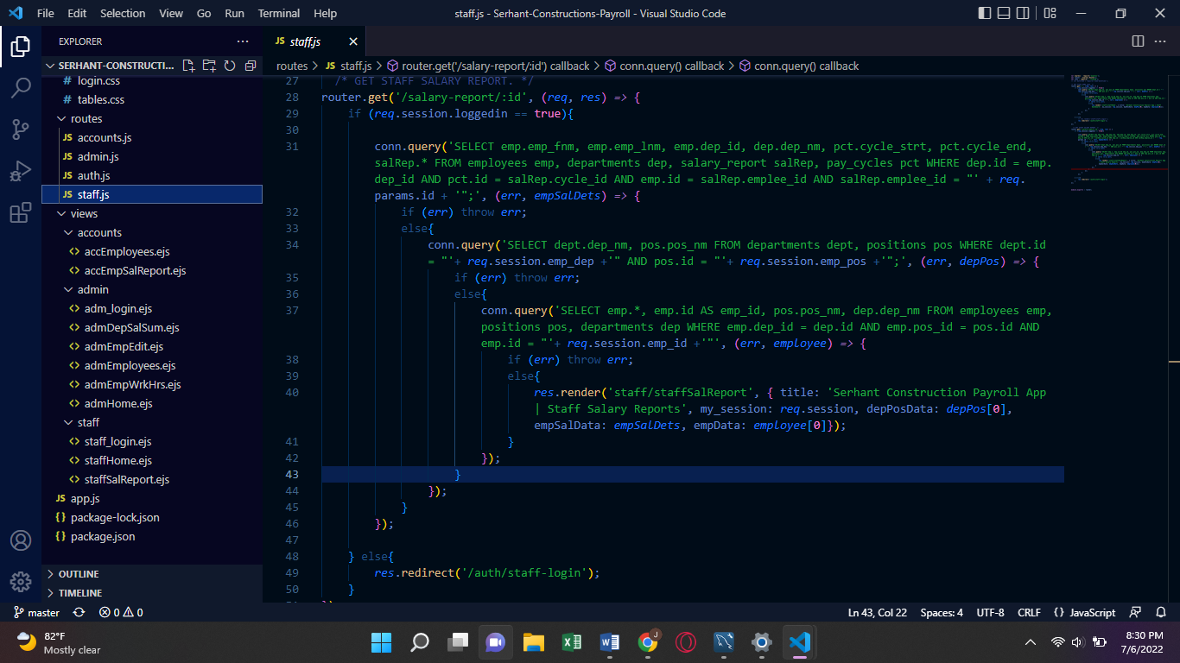

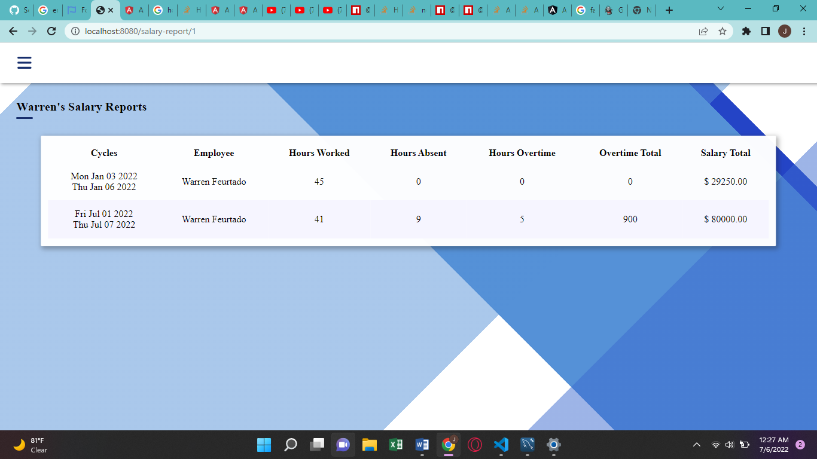

This page will only show the salary report information for the logged in staff member.

**ADMIN LOGIN PAGE**

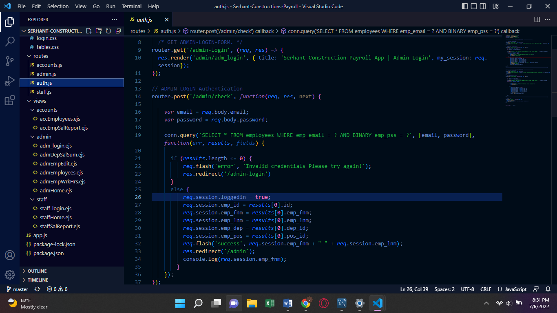

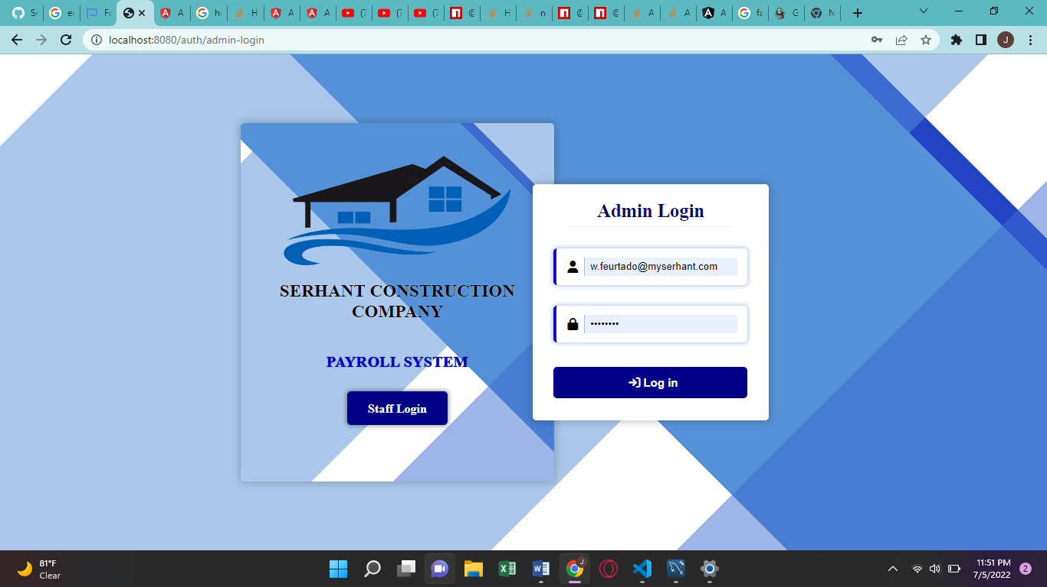

Only Department Supervisors (admin) and accounts department employees (Accountants) may login using the admin login form which would grant access to their respective Dashboard Views.

SUPERVISORS

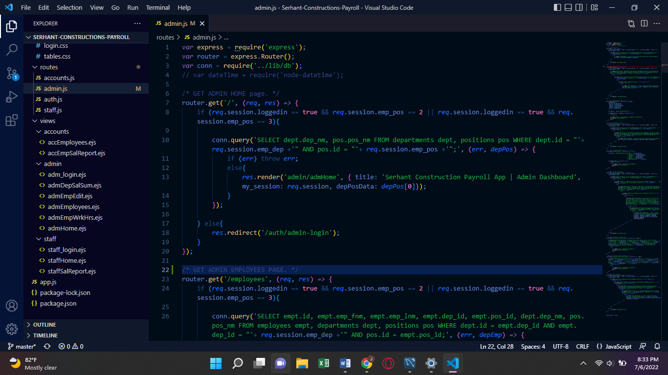

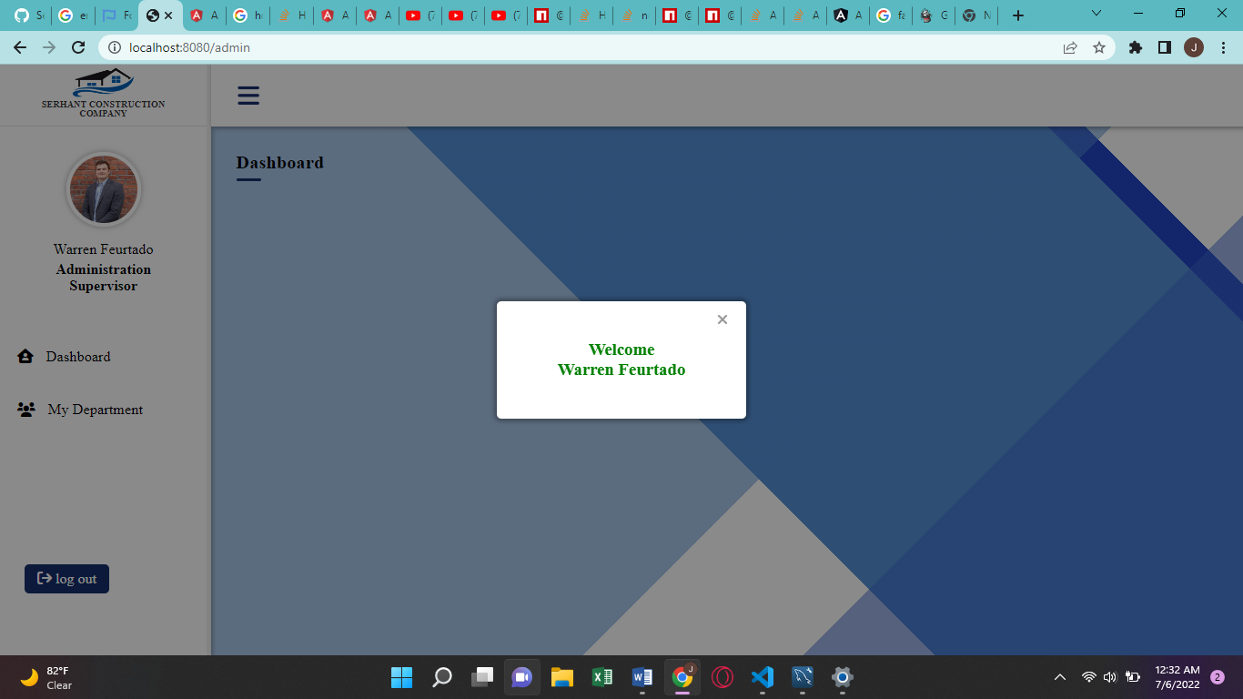

The Supervisor Home Dashboard view operates just the same as the Staff Dashboard view.

The side bar specifies the name department and position of the logged in employee.

Clicking the logo in the top of the side bar will redirect the user to the staff Home Dashboard. Instead of having to logout and navigate to the staff login form to get there.

The “MY DEPARTMENT” button in the side bar offers two links:

* “EMPLOYEES” which takes the supervisor to a page which displays all the employees in their department, along with a form for adding a new employee to that department.
* And “DEPARTMENT SALRY” which takes the supervisor to a page displaying the total salary summary for that department for the active pay-cycle.

**DEPARTMENT SALARY SUMMARY PAGE**

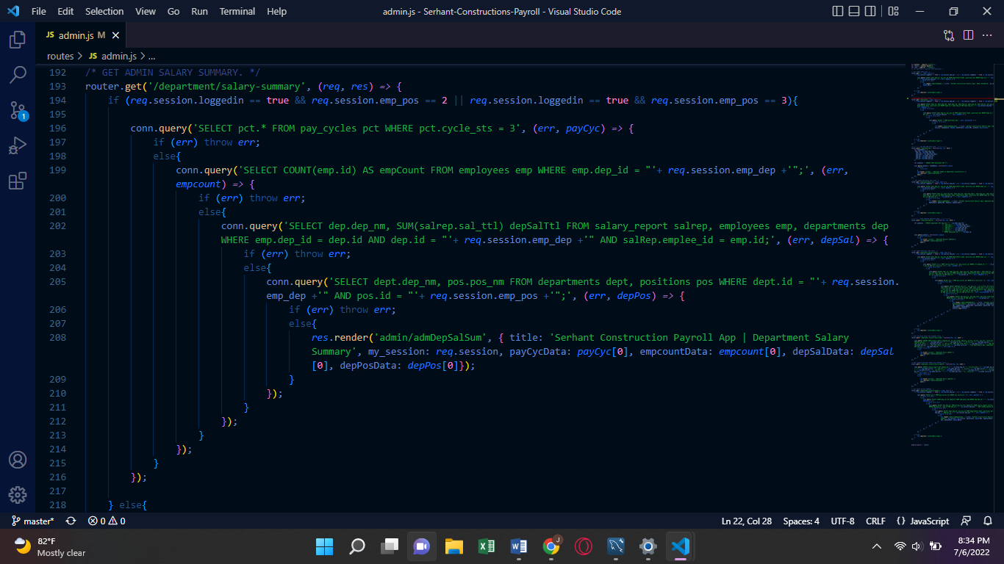

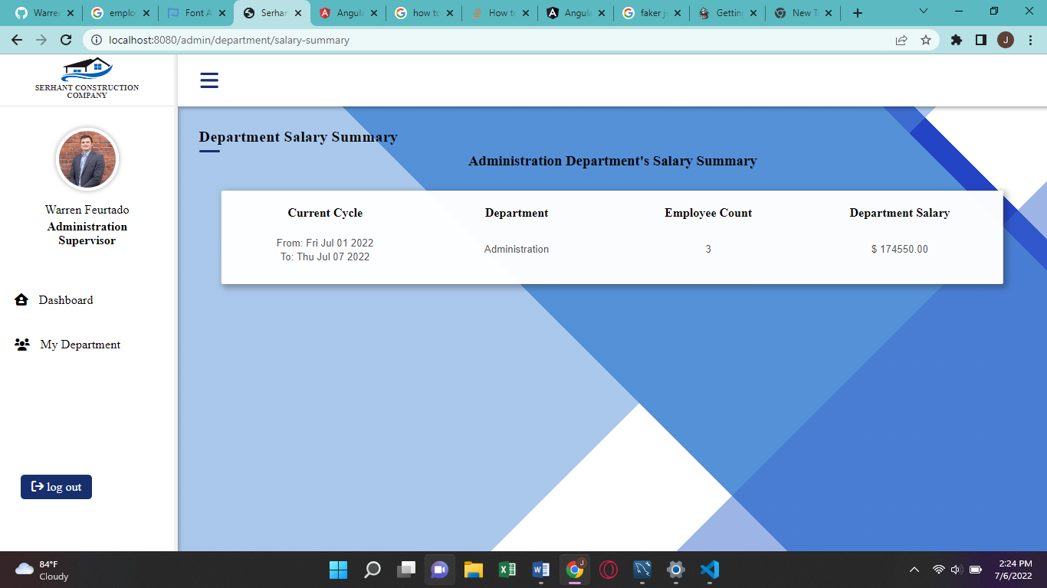

**DEPARTMENT EMPLOYEES PAGE**

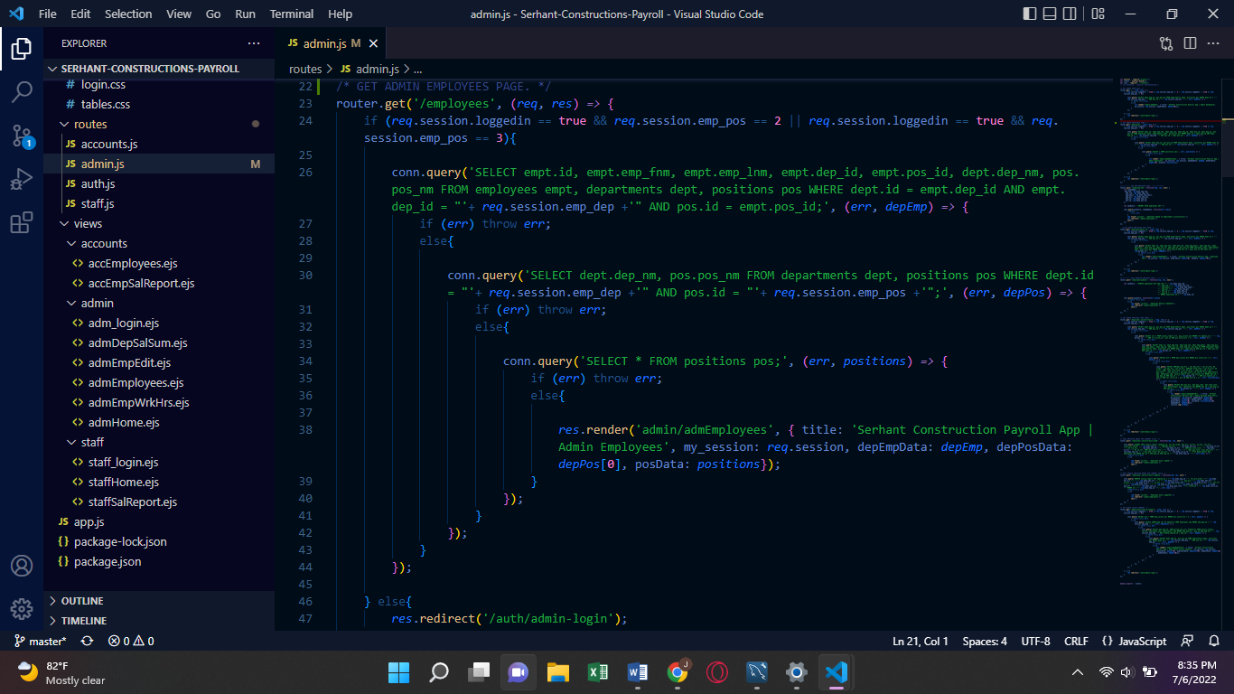

**ADD DEPARTMENT EMPLOYEES**

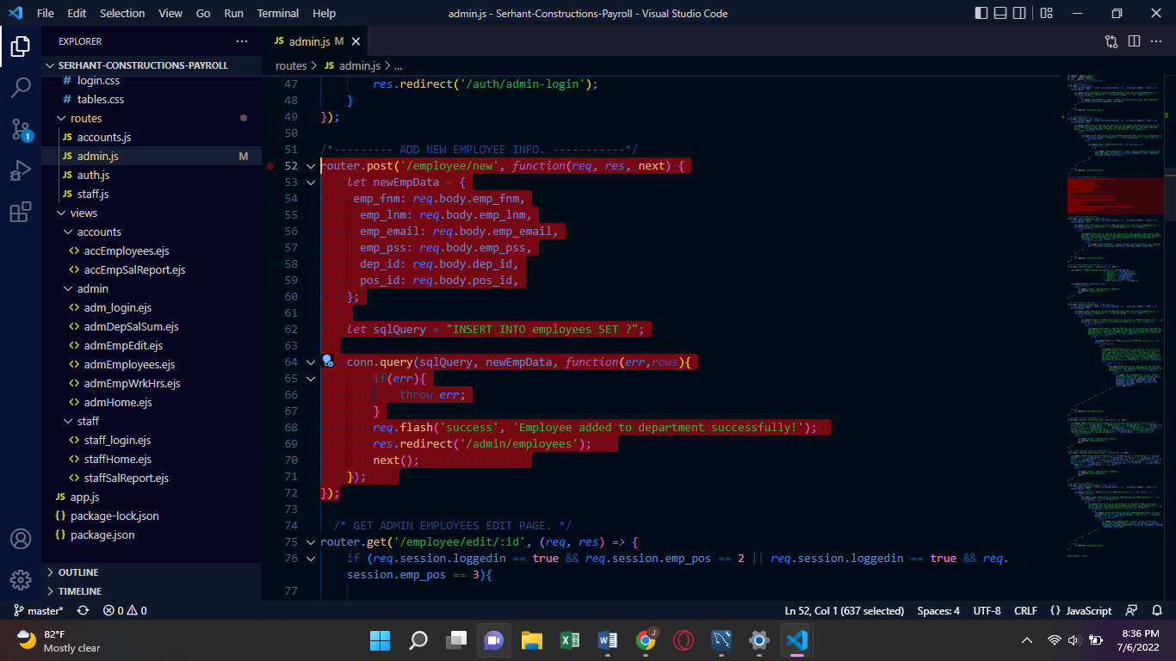

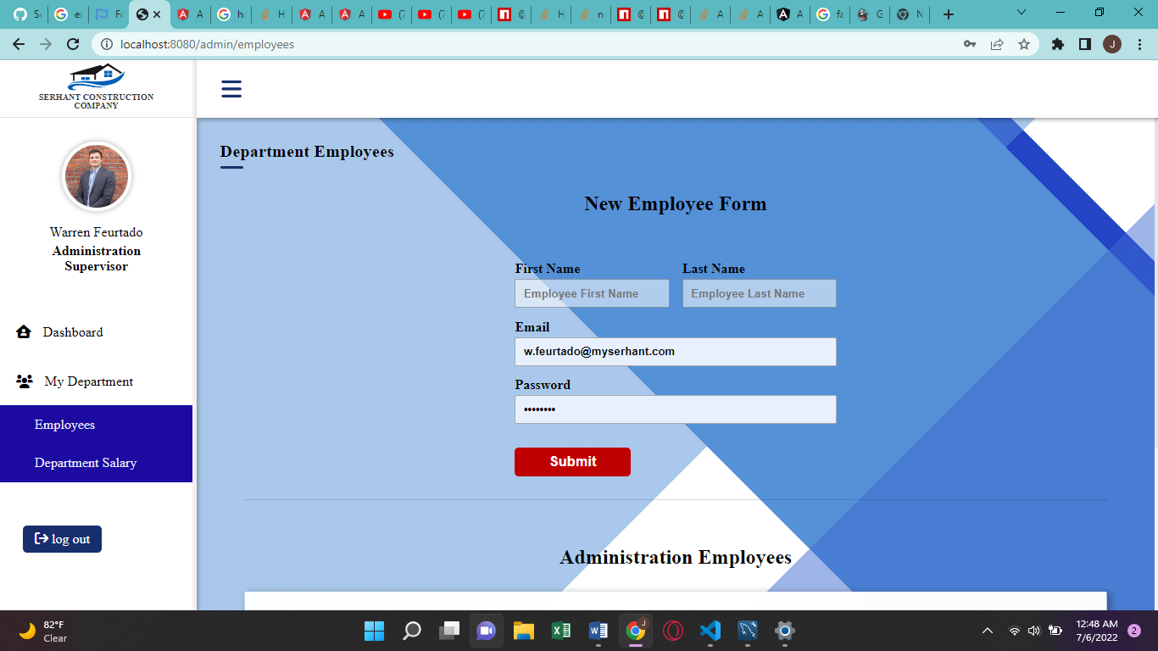

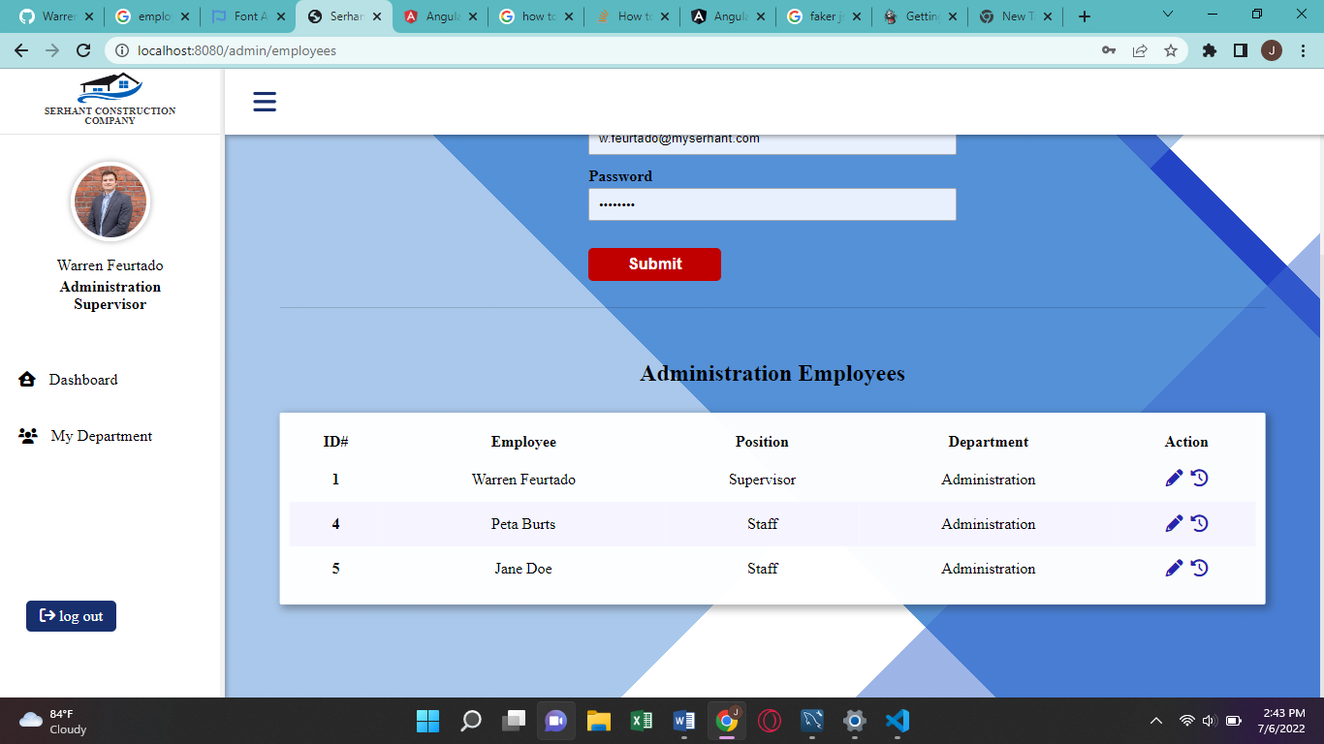

The Department Employees page contains a Form for Supervisors to add a new Employee for their department, and a table right below the form which displays all employees in that Supervisors department.

In the “Action” column of The Department Employees Table, the Supervisor may opt to edit an employee, by clicking on the pencil symbol, or Log / Edit work hours for that particular Employee by clicking on the time symbol.

**EDIT EMPLOYEE INFO**

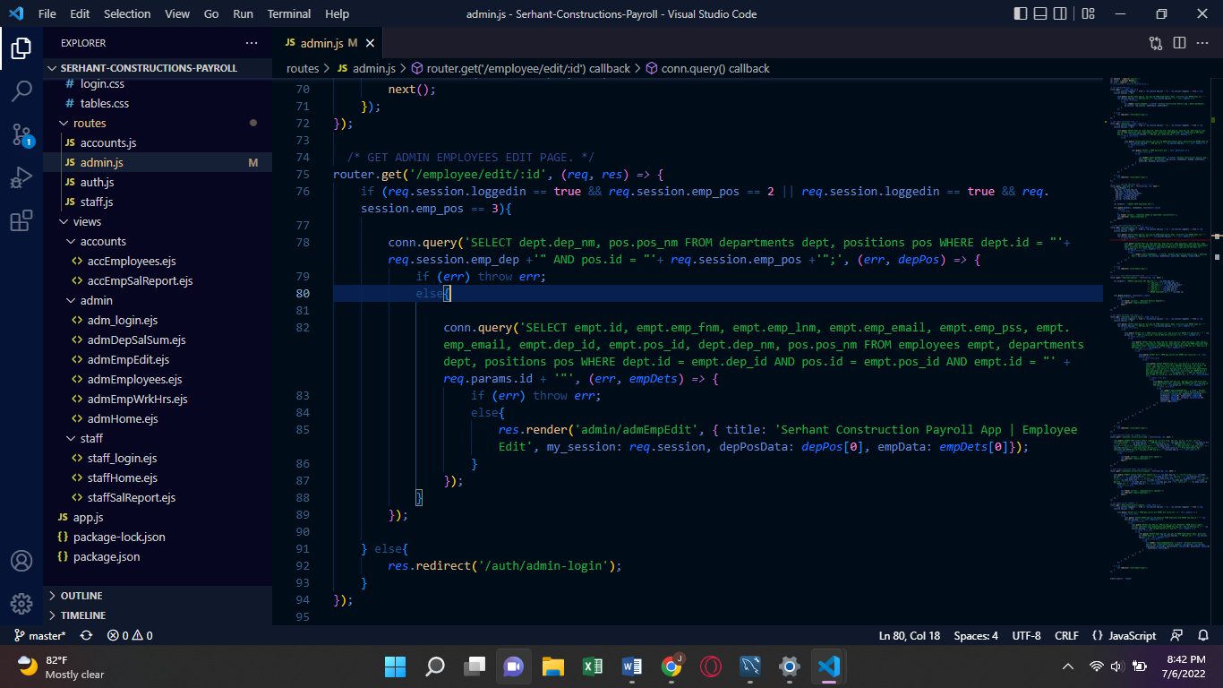

**UPDATE EMPLOYEE INFO**

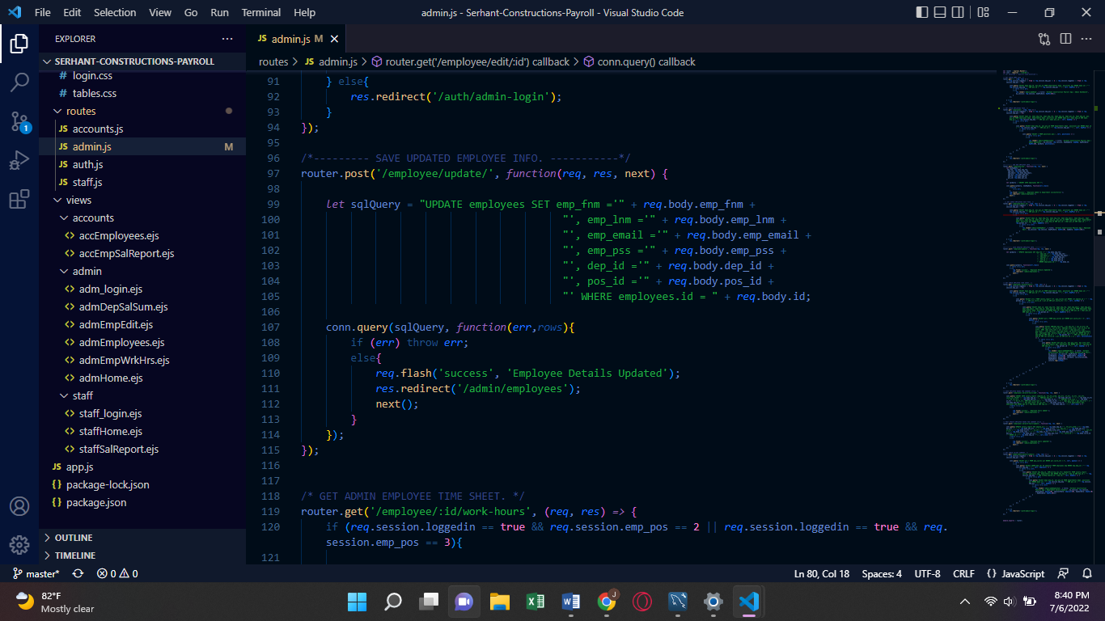

**SUPERVISORS’ EDIT EMPLOYEES PAGE**

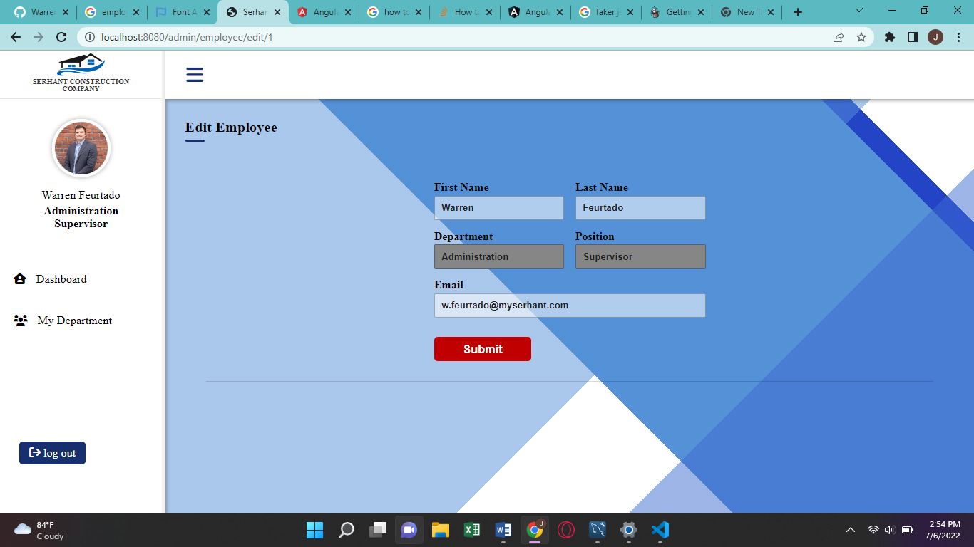

Upon Submition of the edited Employee information the, user is then redirected back to the Department Employees Page where they would be able to see the updated Employee information displayed in the Department Employees Table.

**SUPERVISORS’ EDIT / LOG EMPLOYEE WORK HOURS**

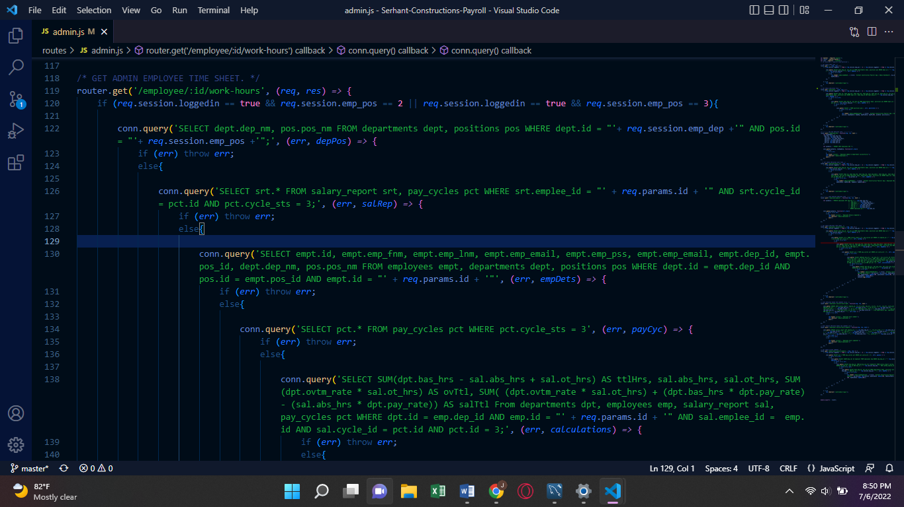

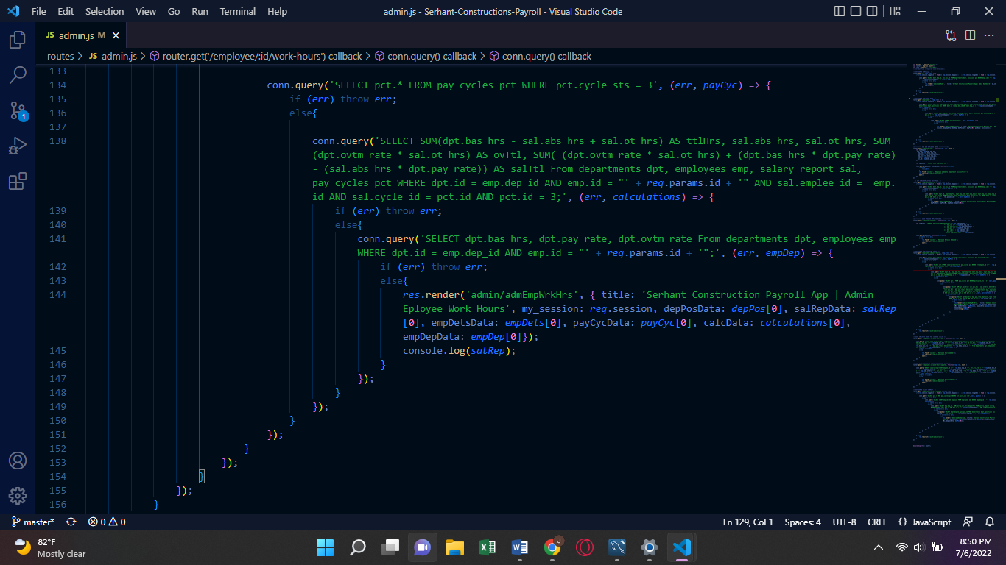

**SUPERVISORS’ EDIT / LOG EMPLOYEE WORK HOURS PAGE**

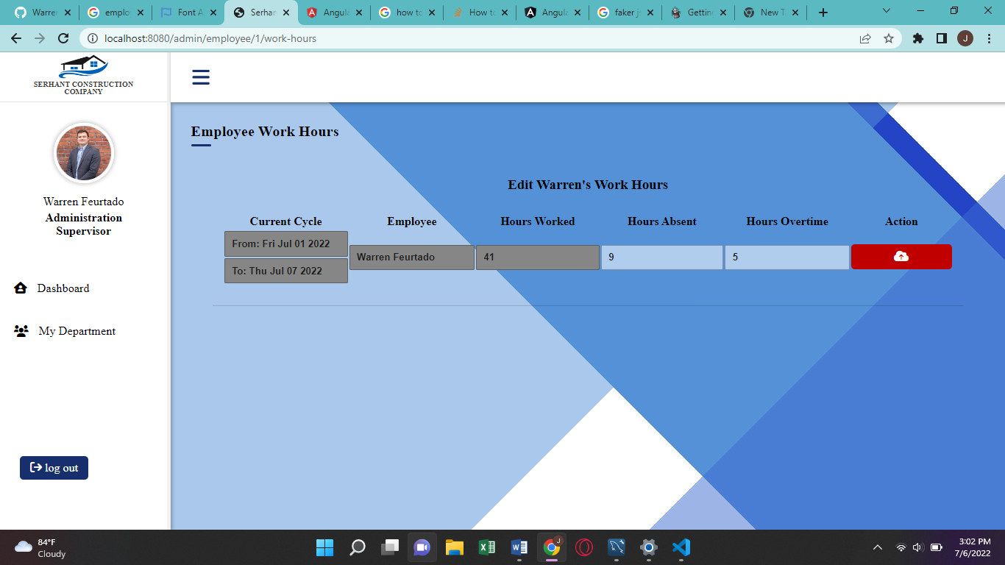

If work hours had already been logged for the selected Employee, this page will allow the Supervisor to edit the Employees Absent Hours and their overtime Hours Worked, but only for the current pay cycle which would have a status of active.

If the selected Employee does not have any hours recorded for the current pay-cycle, then the supervisor would see “Log Work Hours For ‘employee name’” instead of “Edit ‘employee name’ Work Hours’” as shown above.

ACCOUNTANTS

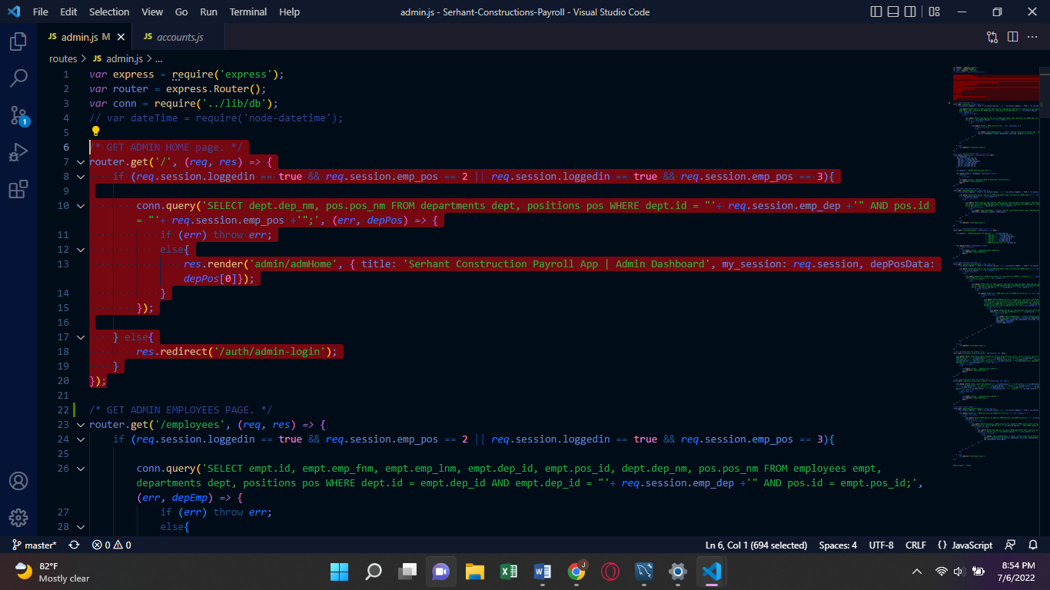

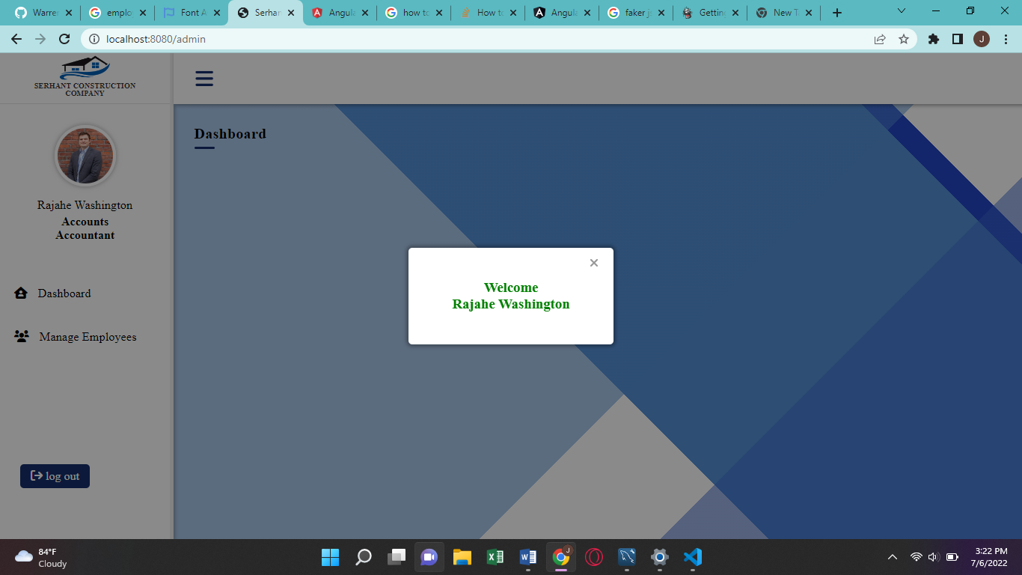

In the side-bar, the Employees Name, Department and Position is also displayed.

The Manage Employees Link takes accountants to a page which displays all the Employees in the company.

**ACCOUNTANTS’ EMPLOYEES PAGE**

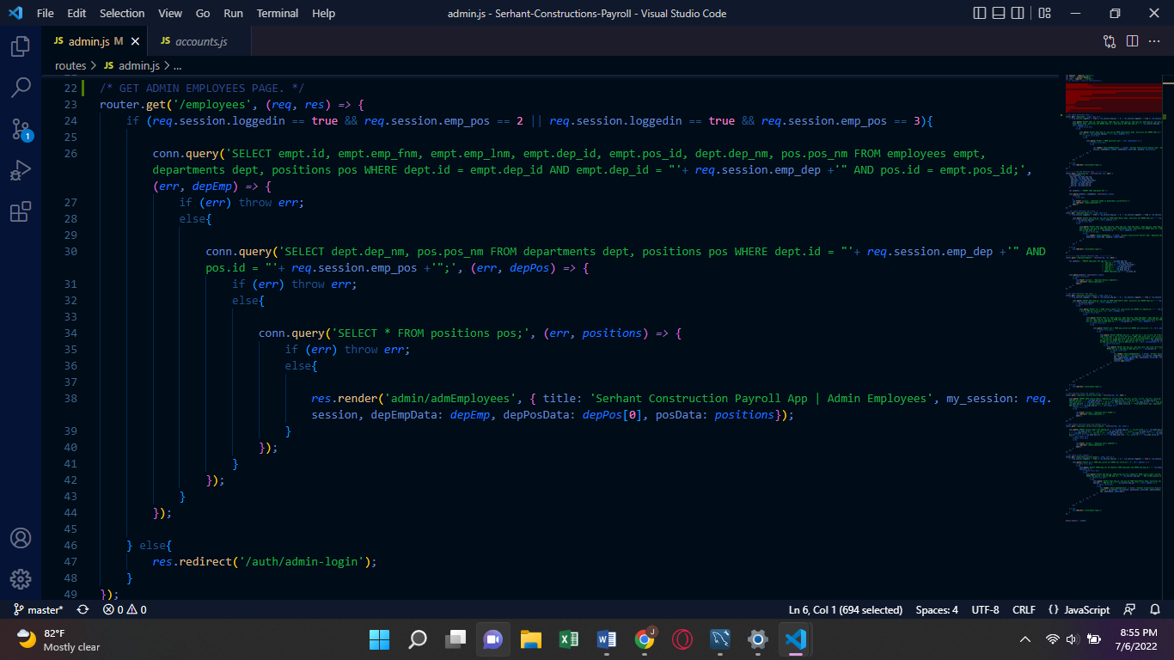

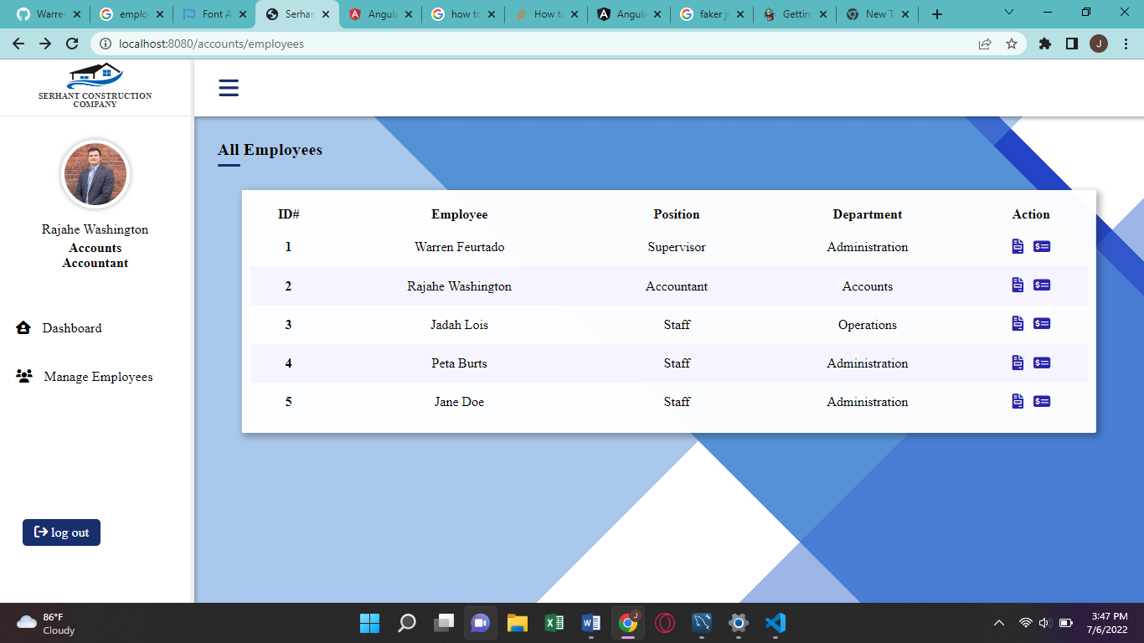

Here an Accountant may view an Employee’s Salary Summaries by clicking on the left icon in the action column of the Employees Table.

**ACCOUNTANTS’ EMPLOYEES SALARY REPORTS PAGE**

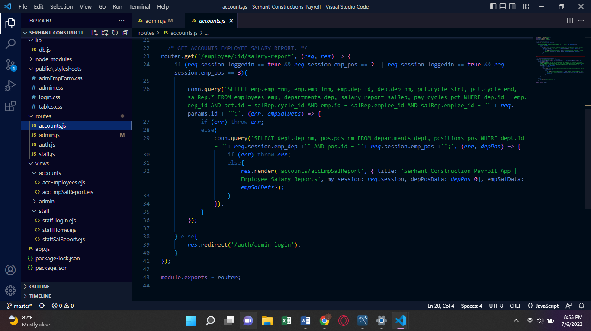

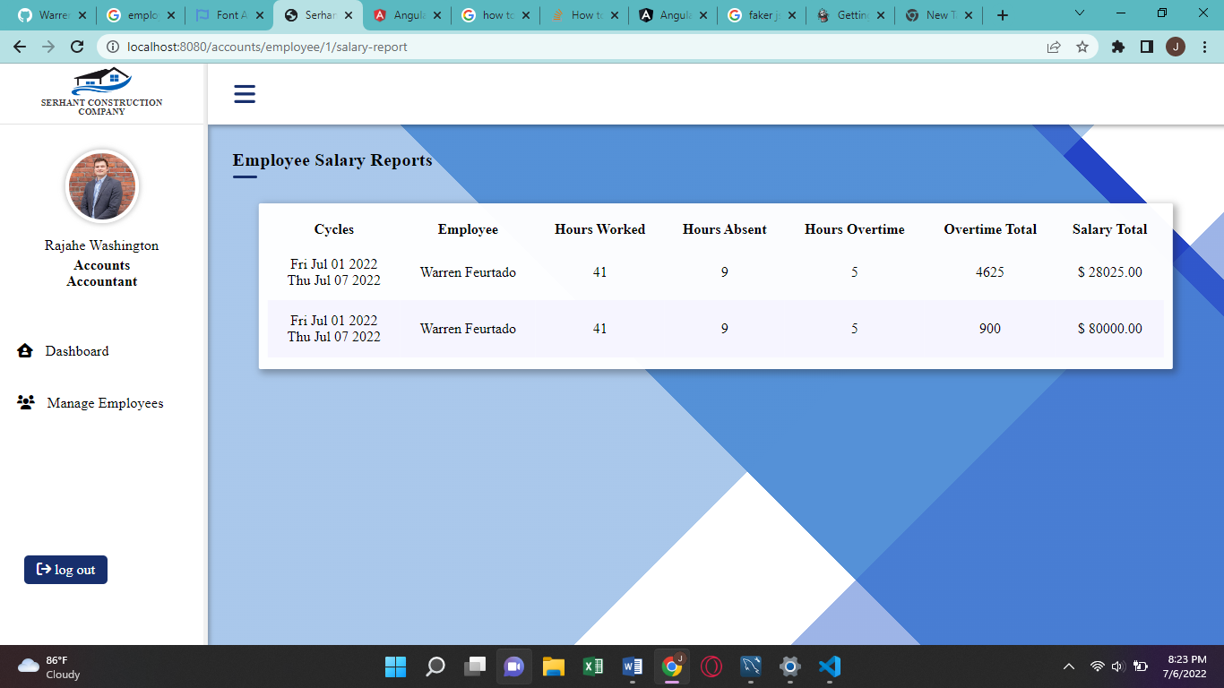

Here the Accounant may view all of an employees Salary reports.